For report 16002765 001, Air cooler: KTD120-80B

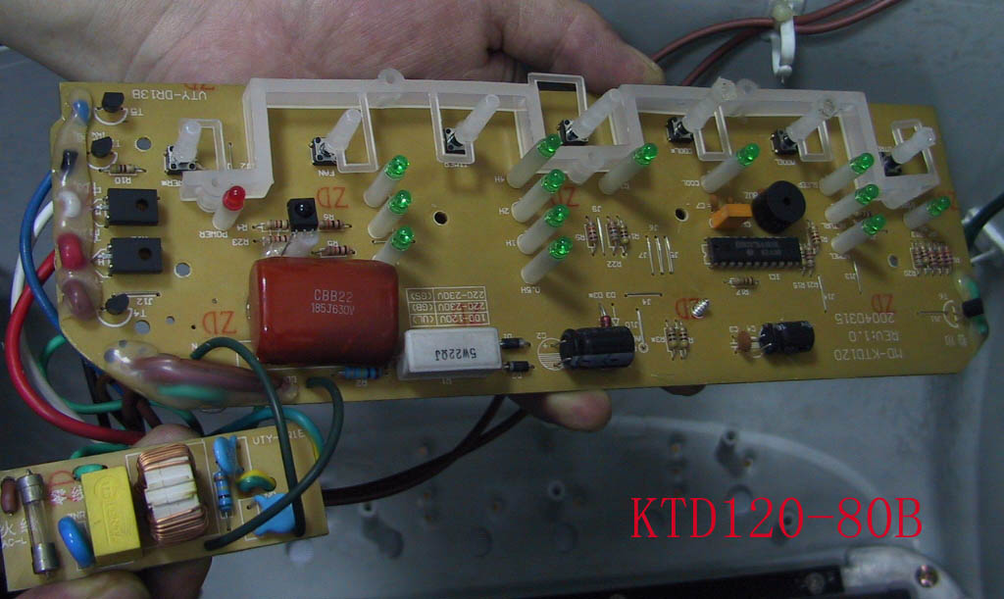

For report 16002765 001, Air cooler: KTD120-80B

